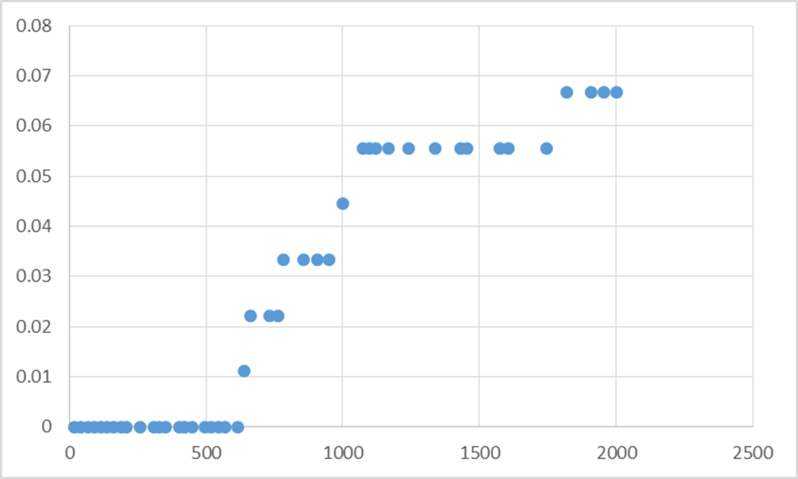

Problem: You run a series of trials. The response to your treatment is sigmoidal (S-shaped), as shown in the graph above. For every trial, you want to know what value of X will yield a Y value exactly halfway between the minimum and maximum values of Y (kind of like an LD50 value, if you’re familiar with that concept).

Goal: Write an R function that could calculate this value for you for any set of data you give it that looks like this.

New Functions to know:

1. glm(). Runs a generalized linear model and uses “formula notation” (see below).

2. coefficients(). Extracts the coefficients from a linear model (see below).

Steps to take:

*Because we don’t want you to spend time learning statistics for this problem, we wrote **all** the code you would need to create this function, but we’ve scrambled the order of the lines. Simply put the lines back in the proper order and the function will work! We’ve provided annotations for each line to help you.

Code:

1. }
2. model1 = glm(Y.vec ~ X.vec, family = binomial) #Runs the logistic regression
3. Y.vec = Y.vec/max(Y.vec) #Dividing every value in Y by Ymax to rescale Y values to 0-1. (Hint: Needs to go before the model1 object is made!)
4. beta1 = coefficients(model1)[2] #Extracts the coefficients from the regression.
5. return(OurX) #Gives us our resulting X value
6. OurX = ((log((target/(1-target)))-beta0)/beta1) #This is the math that calculates our X value.
7. beta0 = coefficients(model1)[1] #Extracts the coefficients from the regression.
8. calculate.target = function(X.vec, Y.vec, target=0.50) {

Function testing:

Use the file “logistic.data1.csv” to test your new function! Save the file to your working directory (ask for help if you don’t know how to do this). Then, run the following code to load and look at the data and then to find the 50% X value that we desire.

logistic.data1 = read.csv("logistic.data1.csv")

attach(logistic.data1)

plot(Y ~ X) #Plots our logistic data.

calculate.target(X.vec=X, Y.vec=Y, target=0.50) #This should return the result we’re after, if your function is working correctly.